**Exercise 12 – RESTful Web Service for Calculator Application**

**Name:** Badri MSV **Roll No:** 195002017

**Subject:** UIT1611 – Web Programming Lab **Faculty:** Dr. S. Sasirekha

**Date:** 14/06/2022

**Aim:**

To write a program to implement RESTful web service for calculator application.

**Procedure:**

* Get the operands using input tag and the operator using option tag.
* The div enclosing the calculator is directed to the corresponding ng-app and ng-controller.
* Have a calculate button whose ng-click is directed to the calculate function in the controller.
* Have a tag for answer which is linked to the result passed by the controller.
* Inside the controller get the operator and pass it to the $http.get function and pass the first and second operands as query params in the get function.
* Store the result in $scope.answer.

**For the Server:**

* Connect to express.
* Based on different paths, route app.get and perform the respective operations.
* Store query first and query second in two variables.
* Convert the variables to numbers.
* Perform the required operation using the two numbers and send the result.

**Javascript:** (Calc.js)

const express = require("express");

const app = express();

app.use(express.static("public"));

app.get("/", (req, res) => {

    res.sendFile(__dirname + "/RESTCalc.html");

});

app.get("/add", (req, res) => {

    var first = req.query.first;

    var second = req.query.second;

    var value = Number(first) + Number(second);

    var result = {result: value};

    res.send(result);

});

app.get("/subtract", (req, res) => {

    var first = req.query.first;

    var second = req.query.second;

    var value = Number(first) - Number(second);

    var result = {result: value};

    res.send(result);

});

app.get("/multiply", (req, res) => {

    var first = req.query.first;

    var second = req.query.second;

    var value = Number(first) * Number(second);

    var result = {result: value};

    res.send(result);

});

app.get("/divide", (req, res) => {

    var first = req.query.first;

    var second = req.query.second;

    var value = Number(first) / Number(second);

    var result = {result: value};

    res.send(result);

});

app.listen(7000);

**HTML:** (RESTCalc.html)

<!DOCTYPE html>

<html lang="en">

<head>

    <meta charset="UTF-8">

    <title>Calculator</title>

</head>

<body>

<script src="https://ajax.googleapis.com/ajax/libs/angularjs/1.3.14/angular.min.js"></script>

<center><h3>CALCULATOR</h3>

    <div ng-app="CalculatorApp" ng-controller="CalculatorController">

        <p><b>Operand 1</b></p>

        <p><input type="number" ng-model="first"></p>

        <p><b>Operand 2</b></p>

        <p><input type="number" ng-model="second"></p>

        <p><b>Choose operation</b></p>

        <p><select ng-model="operator">

            <option value="add">+</option>

            <option value="subtract">-</option>

            <option value="multiply">*</option>

            <option value="divide">/</option>

        </select></p>

        <button ng-click="calculate()">CALCULATE</button>

        <p><b>ANSWER</b></p>

        <p ng-model="answer">{{answer}}</p>

    </div>

</center>

<script>

    angular.module('CalculatorApp', [])

        .controller('CalculatorController', function ($scope, $http) {

            $scope.calculate = function () {

                ops = $scope.operator;

                $http.get(ops,

                    {

                        params: {

                            first: $scope.first,

                            second: $scope.second

                        }

                    }).success(function (res) {

                    console.log('Exit status ' + JSON.stringify(res));

                    $scope.answer = res.result;

                });

            };

        });

</script>

</body>

</html>

**Output:**

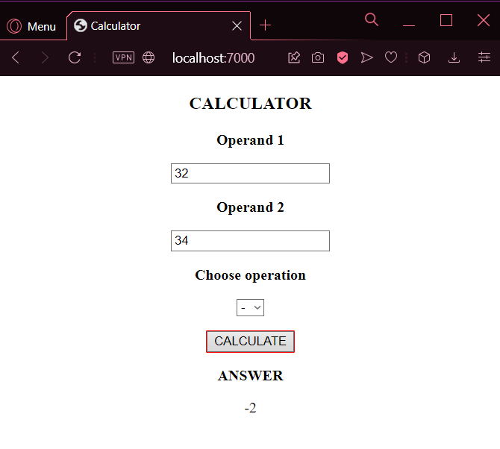 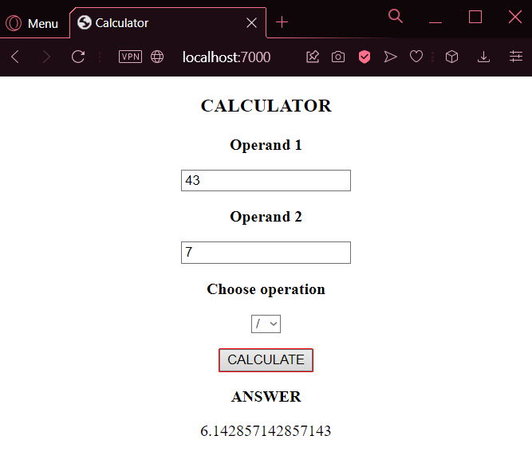

**Result:**

A RESTful web service for calculator application was implemented successfully using node and express.